VICTORIA JUNIOR COLLEGE
JC2 PRELIMINARY EXAMINATION 2026
H2 GEOGRAPHY PAPER 1

MARK SCHEME

1a | Describe the global pattern of uranium production among the countries shown in Resource 1A.
 | [4]
Award 1 mark per description.

- [Production varies considerably between countries] ranges from about 22,000 tonnes in Kazakhstan to very low levels in several countries.
- [Kazakhstan is by far the largest producer] about 22,000 tonnes, substantially more than Canada, the second-largest producer.
- [Canada, Australia and Namibia form a second tier] producing approximately 5,000–7,000 tonnes each.
- [Production declines sharply among the remaining countries] Uzbekistan, Russia and Niger produce around 2,500–3,500 tonnes, while Ukraine, India, South Africa and the USA produce very little.
AO2
1b | With reference to Resources 1A and 1B, suggest reasons why uranium contributes more significantly to GDP in some countries than others.
 | [4]
Award 1 mark for each point and 1 additional mark for further development of each point.

- [Economic diversification] Countries with more diversified economies have a wider range of industries contributing to GDP, so uranium makes up a relatively smaller proportion of total economic output. For example, the USA, Canada and Australia have substantial manufacturing and service sectors alongside resource extraction, reducing the relative contribution of uranium to GDP.

- [Dependence on extractive industries] Uranium contributes more significantly where the economy is more dependent on mining and other extractive activities. For example, Namibia and Niger have economies in which mining is an important source of economic activity and export earnings; consequently, uranium accounts for a relatively larger share of GDP.

- [Relative size of the economy] The contribution of uranium depends on the size of the overall economy, not simply the quantity of uranium produced. A similar value of uranium output will represent a greater share of GDP in a smaller economy. This helps explain why Namibia has a higher uranium-to-GDP contribution than Kazakhstan, despite producing considerably less uranium.

- [Importance of other economic sectors] Where other sectors make a large contribution to GDP, uranium becomes relatively less significant. For example, Kazakhstan produces the most uranium, but its large oil and gas sector and other economic activities mean that uranium accounts for only about 1% of GDP, compared with around 4% in Namibia.
1c | With reference to Resource 2, explain how the production and trade of uranium create interdependence between Niger and France.
 | [4]
Award 1 mark for each point and 1 additional mark for further development of each point.

- [Resource flow] Niger exports uranium to France; Resource 2 states that Niger accounted for 15% of French uranium imports in 2022. This creates a flow of an important raw material from Niger to France.
- [Capital and investment flows] French state-owned company Orano operates the Arlit uranium mine in Niger, creating flows of French capital, technology and expertise into Niger's mining sector.
- [Economic dependence] Niger depends on uranium mining and exports for export earnings and economic activity, while France benefits from access to uranium for its nuclear energy sector.
- [Mutual dependence] Niger's uranium production is therefore linked to French demand, while France relies partly on Nigerian uranium supplies; disruption to either the supply or demand side could affect the other country.

AO2

1d | Suggest some impacts of natural resource extraction in less developing countries.
 | [6]
Award 1 mark for each point and 1 additional mark for further development of each point.

- [Economic growth and export earnings] Natural resource extraction can generate export revenues, government revenue and foreign exchange, contributing to economic growth. For example, uranium exports can provide an important source of revenue for countries such as Niger and Namibia.
- [Employment and infrastructure] Extraction can create direct and indirect employment and encourage investment in infrastructure such as roads, railways, electricity and ports. However, the capital-intensive nature of mining means that relatively few jobs may be created compared with the scale of investment.
- [Economic dependence] Heavy reliance on natural resources can make LEDCs vulnerable to fluctuations in global commodity prices and demand. A fall in prices can reduce export earnings and government revenue, making economic development more unstable.
- [Environmental degradation] Mining and extraction can cause land degradation, habitat destruction, water pollution and soil contamination. For example, uranium extraction can create radioactive waste and contamination risks if mining waste is poorly managed.
- [Social impacts] Resource extraction can improve local incomes and access to services, but may also lead to displacement, inequality and conflict over land and resource revenues, particularly where local communities receive few benefits.
- [Political impacts] Valuable resources can increase the power of governments and foreign companies, but may also encourage corruption, rent-seeking or conflict over control of resource revenues, particularly where governance is weak.

AO1

1e | Using Resource 3, describe the spatial organization of Orano, a French energy TNC that sources uranium from around the world.
 | [6]
Award 1 mark for each elaborated point.

Orano therefore has a globally organised production network, with extraction and suppliers dispersed across resource-rich countries, while HQ, higher-value production/coordination and major customers are concentrated in France/Europe.

[HQ – France] Orano’s HQ is located in France, where it coordinates and manages its global uranium production network.

[Extraction- globally dispersed] Uranium is extracted from resource-rich countries around the world, including Canada, Niger, Kazakhstan and Namibia, providing raw material for Orano.

[Suppliers- resource-rich countries] Orano works with local governments and mining companies as suppliers/partners, e.g. in Niger and Kazakhstan, allowing it to access uranium resources overseas.

[Production- France/Europe) Extracted uranium is transported through Orano’s processing and production network, including uranium conversion and fuel fabrication.

[Customers- concentrated in Europe] The finished nuclear fuel is supplied mainly to European customers, particularly nuclear utilities that use it to generate electricity.

 | AO2
1f | Explain the factors that may have contributed to Orano’s spatial organisation.
 | [6]
Award 1 mark for each factor and 1 additional mark for further development of each point.

- [Resource availability – extraction sites] Orano’s extraction sites are located in resource-rich countries such as Canada, Niger, Kazakhstan and Namibia, because uranium is geographically unevenly distributed. Locating extraction close to deposits gives Orano access to the raw material needed for its downstream production.

- [Comparative advantage – lower production costs] Orano may locate uranium extraction in countries where suitable deposits can be mined relatively economically, allowing it to reduce extraction costs and maintain competitiveness within the global uranium market.

- [Historical factors – established mining operations] Orano’s spatial organisation has been shaped by its long-standing presence in particular countries. For example, uranium mining in Niger dates back to the establishment of SOMAIR in 1968, creating established infrastructure, expertise and relationships that support continued extraction.

- [Government / political factors – access to resources] Orano works with host governments and local partners, such as in Niger and Kazakhstan. Government agreements and partnerships can provide Orano with access to uranium resources, influencing where it establishes extraction operations.

- [Market access – proximity to customers] Orano’s downstream activities and customers are concentrated in France/Europe, where there is significant demand for nuclear fuel. Locating processing, fuel fabrication and distribution within or near Europe facilitates access to major European nuclear utilities.

- [Agglomeration / existing infrastructure – production] Orano’s HQ and downstream production activities in France can benefit from existing skilled labour, technological expertise, infrastructure and nuclear-industry clusters, supporting higher-value functions such as processing, fuel fabrication and management.

- [Global production networks – specialisation] The spatial organisation reflects a global division of labour, where different locations specialise in different stages of the production process. Resource-rich countries specialise in uranium extraction, while France and Europe undertake coordination, processing and production activities, and European countries form an important market for the finished products. This allows Orano to exploit the different locational advantages of places across its global network.

AO1

Qn | Answer | Marks
2a | With reference to Resource 1, explain the conditions that led to the development and path of Typhoon Bavi.  Award 1 mark for each point and 1 additional mark for further development of each point. A maximum of 3 marks can be awarded for explanation of development or path.  Conditions that led to development:  - It being summer in the Northern Hemisphere in July, there was sufficiently warm sea surface temperatures [1] in the western Pacific (Pacific Ocean, Philippine Sea, South China Sea) which provided the essential energy source for the storm’s formation. [1]  - Latitude north of the equator allowed for sufficient Coriolis effect to generate rotation. [1] The centrifugal forces created an intense low pressure which continues to draw warm moist air into the tropical cyclone. [1]  Conditions that led to path:  - Prevailing easterly trade winds [1] along with the Coriolis effect that causes the storm to spin in an anticlockwise direction in the Northern hemisphere cause it to move westward from the Philippines towards China. [1]  AO2 | 6
2b | With reference to Resource 2, describe the natural and human factors that led to the mass movement.  Award 1 mark for each point and 1 additional mark for further development of each point. The answer should cover at least one natural and one human factor.  Natural factors:  - Rainfall: Heavy continuous rainfall brought by the typhoon added weight to the slope, increasing shear stress. [1] Saturated soils also have greater pore water pressure and reduced friction between particles, reducing shear strength. [1]  - Vegetation: The slopes are heavily vegetated with trees that can add significant weight to the slope, increasing shear stress. [1]  - Geology: The steep gradients of the slopes cause greater forces exerted by the weight of the material under the influence of gravity acting in a downslope direction, thus increasing shear stress. [1]  Human factors:  - Road construction: The construction of roads in areas could either steepen the slopes further, increasing shear stress [1] or lead to the removal of support at the bottom of hillslopes, decreasing shear strength. [1]  - House construction: The location of homes on hillslopes add weight to the slopes, increasing shear stress. [1]  The mass movement occurred due to the above factors causing the shear stress to exceed the shear strength of the slopes. [1]  AO2 | 6
2c | Contrast the characteristics of meandering and braided rivers.  Award 1 mark for each comparative point (differences only).  Possible comparisons:  - Meandering rivers are single channeled, while braided rivers are multi channeled. [1]  - Meandering rivers tend to be more sinuous than braided rivers. [1]  - Meandering rivers generally have constant discharge, while braided rivers have fluctuating discharge. [1]  - Meandering rivers deposit their sediments on the inner bank as slip off slopes, while braided rivers deposit their sediments in the middle of the river channel as mid-channel bars. [1]  - Meandering rivers are more common in the humid tropics, while braided rivers are more common in periglacial regions. [1]  AO1 | 4
2d | With the use of an annotated diagram, explain why meander bends have asymmetrical cross-sectional profiles.  Award 2 marks for accurate drawing of diagram with the inner and outer bank labelled with the slip off slope and river cliff respectively.  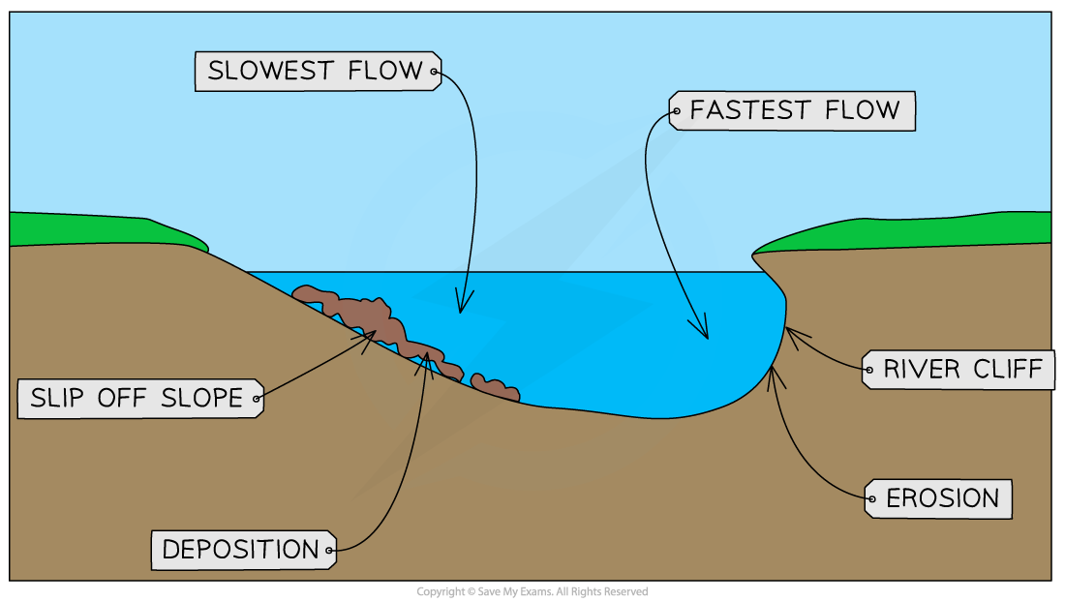  Award 1 mark for each annotated point, and 1 additional mark for further development of each point  - The impinging of the thalweg on the outer bank causes erosion due to higher energy, forming a river cliff with a steeper gradient. [1]  - Slower flow on the inner bank leading to more deposition due to lower energy, forming a slip off slope with a gentler gradient. [1]  - Helicoidal flow also transports some of the eroded material from the outer bank across to the inner bank where it is deposited, reinforcing the asymmetrical profile. [1]  AO1 | 5
2e | With reference to Resource 6A and 6B, describe the characteristics of the Yangtze River Delta.  Award 1 mark for each point.  Possible descriptions:  - The is a wide delta plain approximately 140km in width. [1]  - The delta plain is covered in vegetation in the North where the townships of Chongming, Qidong and Haimen are located. [1] In the South where Shanghai is located, the delta plain is highly urbanised. [1]  - There are multiple distributaries on the delta plain [1] that flow in an eastward direction towards the East China Sea. [1]  - There are multiple elongated bars perpendicular to the coastline, the largest of which is Chongming. [1]  - The delta front is visible off the coast of the delta plain in shallow water where there is evidence of light brown sediment being deposited. [1]  AO2 | 5
2f | Explain the possible impacts Typhoon Bavi could have had on the ecosystem services of the Yangtze River Delta.  Award 1 mark for each point and 1 additional mark for further development of each point. The answer should cover at least two ecosystem services.  The storm surges and strong winds of tropical cyclones would damage the natural landscapes which would negatively impact:  - [Regulating ecosystem services] With less coastal vegetation available to bind the soil together and stabilise the coastline [1], the delta would be less capable of protecting the land against waves and sea level rise. [1]  - [Regulating ecosystem services] With fewer plants, less atmospheric CO2 will be captured and stored [1], thus undermining its function as a carbon sink. [1]  - [Supporting/Cultural] Damage to the coastal vegetation would threaten the habitats of aquatic and land animals that make the delta their home. [1] The fall in biodiversity could in turn reduce its ability to function as an important educational or research site. [1]  AO2 | 4

3 | Assess the factors that contribute to transboundary water conflicts. | [20]
Candidates could approach the question by making a judgement on the factors that contribute to transboundary water conflicts through consideration of both physical and human factors.

Candidates could evaluate the role of physical factors such as water scarcity, spatial and temporal variations in precipitation and the location of water resources across drainage basins, as well as human factors such as increasing water demand from population growth, urbanisation and economic development.

Candidates could also consider the role of political, economic and historical factors, including the unequal distribution of water resources and power between riparian states, competing national interests, water governance and the absence or effectiveness of transboundary water agreements.

Candidates should evaluate which factors are most significant in contributing to conflict, recognising that the relative importance of these factors varies according to contextual factors such as the level of water scarcity, the degree of dependence on shared water resources, the number and power of riparian states, and the effectiveness of cooperation and water management institutions.

Levels marked using Generic Level Descriptors for H2 essays.

AO3

4 | “TNCs have reduced the significance of the state in the global economy. Evaluate this statement.” | [20]
Candidates could approach the question by making a judgement on whether the increasing influence of TNCs has reduced the significance of the state in the global economy through consideration of the changing roles of TNCs and states in shaping economic activity.

Candidates could evaluate how TNCs may reduce state influence through their ability to move capital and production across national borders, influence investment and employment, and organise economic activity through GPNs that transcend national boundaries.

Candidates could also evaluate the continued significance of states through their ability to regulate TNC activity, attract and shape FDI, provide infrastructure and skilled labour, negotiate trade agreements and implement economic and industrial policies.

Candidates could consider the extent to which states and TNCs are mutually dependent, with states providing the conditions necessary for TNC activity while TNCs contribute to investment, employment, technology and integration into the global economy.

Candidates could also evaluate how the relative significance of TNCs and states varies according to contextual factors such as the level of development, economic size and bargaining power of the state, the sector and nature of TNC activity, and the degree of dependence on TNC investment.

5 | “Fluvial floods can always be prevented.” Evaluate this statement.  Candidates could approach the question by making a judgement on whether fluvial floods can always be prevented through consideration of the natural (heavy rainfall, snowmelt) and human factors (landuse change – urbanization, deforestation, dam failures) contributing to the occurrence of floods. Candidates could evaluate which factor is most significant in contributing to the occurrence of floods and if they are largely beyond the control of humans. Candidates could also evaluate the effectiveness of flood management measures in preventing floods, as well as the contextual factors such as the magnitude of the flood and a country’s financial capabilities in investing in flood management, which can influence the extent to which the flood can be prevented.  Levels marked using Generic Level Descriptors for H2 essays  AO3 | 20
6 | ‘Geology is the most important factor influencing the formation of karst landscapes in the humid tropics.’ Evaluate this statement. [20]  Candidates could approach the question by making a judgement on whether geology is the most important factor influencing the formation of karst landscapes. They could consider other factors such as climate, sea level rise, tectonic uplift in leading to the formation of karst landscapes. Candidates could also make a judgment on whether some factors play a greater role in some contexts than others (e.g. sea level rise in formation of marine karsts, tectonic uplift for the formation of cockpit karsts) or over larger spatial and temporal scales (e.g. climate in influencing rates of weathering and vegetation) through a consideration of two or more case studies.  Levels marked using Generic Level Descriptors for H2 essays  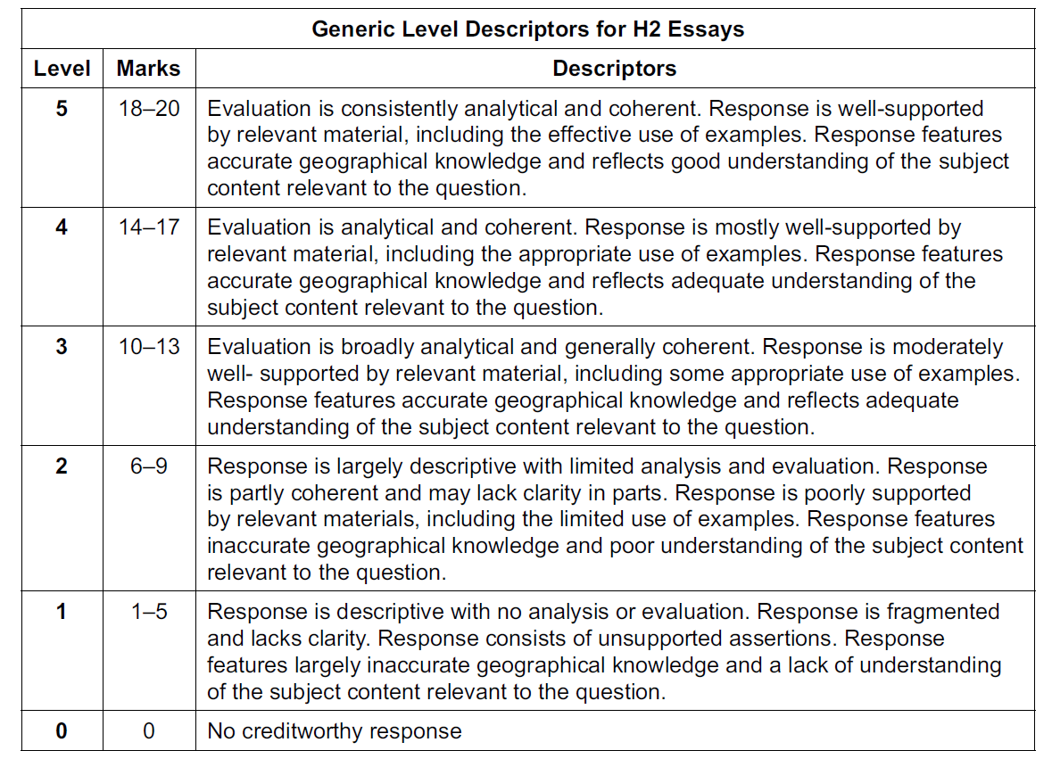  AO3 | 20

Overview of AOs (guidelines in brackets)

 | AO1 (25m) | AO2 (35m) | AO3 (40m)
1(a)
1(b)
1(c)
1(d)
1(e)
1(f)
2(a) |  | 6
2(b) |  | 6
2(c) | 4
2(d) | 5
2(e) |  | 5
2(f) |  | 4
3 or 4 |  |  | 20
5 or 6 |  |  | 20
Total |  |  | 40

